**Kol simcha torah gazette**

**For parshas chaya sarah 5784**

Volume 8 Issue 9 (Whole #367) 27 Mar Cheshvon 5784/ November 11, 2023

**Printed L’illuy nishmas Nechama bas R’ Noach, a”h**

For a free subscription, please forward your request to [***keren18@juno.com***](mailto:keren18@juno.com)

***Past emails can be found on the website ShabbosStories.com under Brooklyn Torah Gazette***

**“Out of the Terrible Pain Will Come Great Salvation.”**

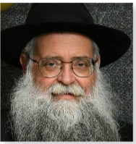

**Rabbi Moshe-Zeev Pizem**

For almost forty years, Rabbi Moshe-Zeev Pizem, has been the director of the Chabad Center in Sderot, located directly on the Gaza border. Over the years he and his family have endured and witnessed many difficulties. Even during the most challenging times he never once thought of leaving the city, and now he says, is no different. He, together with his family are committed to do anything and everything possible, to support, comfort and uplift the spirits of the Sderot residents regardless of the horrific situation they are now faced with.

Rabbi Pizem recalls the various accounts which took place the night of Simchat Torah: With roughly two hundred people in attendance, all participating after services, in the Hakafot dancing which went on until the wee hours of the night, there was tremendous joy in the synagogue. Tired and inspired, we each went home smiling from ear to ear with anticipation for even greater joy the following morning, sadly this joy never came.

**Loudspeakers Warning that Terrorists Were Loose on the Streets**

Early morning greeted us with deadly sounds of shots being fired, coupled with multiple explosions. We have unfortunately heard similar sounds in the past but this was different. Suddenly, we heard an announcement over a loudspeaker notifying residents not to leave the houses, because terrorists are loose on the streets.

“Could this be?” I asked myself, “am I being delusional?”. But then, my family and I saw from the window, terrorists with automatic machine guns shooting anything in sight. My wife and I did what we could to protect the children, and did not stop praying.

Later that Simchat Torah morning I was finally able to return to the synagogue for morning services, accompanied by a number of brave soldiers. When we entered, there were nine Jews waiting for us. Everyone was in a daze, no one really knew what was going on either. Being that I was the tenth for the Minyan we closed the doors and our eyes and prayed to G-d.

Meanwhile, all around us there were explosions and proclamations of red alert and war. The prayers and Hakafot dancing were intense, emotional and yes, they were quick. As it turns out, the city of Sderot was severely attacked. Dozens of residents were killed by the terrorists. Many of our good friends, close residents, police personnel and soldiers, were taken from us in a most horrific and barbaric way. In addition, community members who were an inseparable part of the activities at the Beit Chabad, who were such an integral part of our happy circle of friends, were brutally murdered. The magnificent police station, recently inaugurated, was taken over and subsequently utterly destroyed by the inhumane terrorists.

**A Chilling Thought that Demands a Real Response**

On Sunday at noon, we began assisting with the efforts of finding and identifying those who were murdered. We were subject to scenes we had never seen before and please G-d will never see again. I reiterate, to think that in the Holy Land, our Land, terrorists would roam the streets freely? This is a chilling thought which demands a real response.

We all have painful questions, but now is not the time for questions, now is the time that we must and we are making every effort to strengthen the residents of Sderot. In the past, when Israel went through trying times, the Lubavitcher Rebbe imbued us with the message of hope, faith, confidence, commitment to G-d, our land and our people. He urged Israel to resolutely protect her borders, while at the same time adding to our daily Torah study, prayer, charity and faith in G-d.

There is no doubt in my mind that just as G-d has shown the world over the past 4000 years that the Jewish nation will come out stronger than ever after being confronted by an enemy, that he will do the same this time. The bigger the disaster, the bigger the victory, the greater the calamity, the greater the after blessing! The hope we are all feeling now is the birth of the unprecedented unity that the Jewish people are experiencing now.

My concluding message is: let us come together and help each other whichever way we can, physically, mentally, emotionally, materially or spiritually. Everyone was created by G-d with something that the other person doesn’t have, take that “something” and gift it to a person in need.

And right now, that person is in the Holy Land, whether it’s a mother, father, child, soldier, we need you and are asking for your help even if it’s just picking up a book of psalms and reciting a chapter for the safety and security of our brothers and sisters in the holy land, the incredible IDF, the safe return of our hostages and peace in our land AMEN! Translated from Sichat Hashavua.

*Reprinted from the Parshat Vayeira 5784 edition of L’Chaim.*

***And Efron lived among the Hittites* (Gen. 23:10)**

According to Rashi, "That very day [the Hittites] appointed theirfellow countryman Efron ruler over them, because of the importance of Abraham." Unfortunately, this is a common and recurring theme in Jewish history: Each time an "Efron" is elected to a powerful political post in the Jews' merit, he forgets his debt to "Abraham" as soon as he assumes his position. (Ma'ora Shel Torah)

And the man took a golden earring of half a shekel weight, and two bracelets for her hands of ten shekels weight of gold (Gen. 24:22)

The gifts that Eliezer gave to Rebecca were fraught with meaning: the "half shekel" alluded to the half shekel the Jews would be required to contribute to the Sanctuary, while the "two bracelets" alluded to the Tablets of the Law. The half shekel is symbolic of tzedaka (charity), which is considered so great that it contains within it all the other commandments; the Tablets are symbolic of the entire Torah. The gifts were thus an allusion to the foundation of the Jewish home: the performance of mitzvot, and the study of Torah. (Likutei Sichot)

**Rav Avigdor Miller on How Could Hashem Ask Avrohom**

**To Sacrifice His Son Yitzchok?**

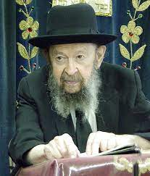

**QUESTION:** How could Hakodosh Boruch Hu ask Avrohom Avinu to sacrifice his son, Yitzchok? Isn’t that too extreme of a demand?

**ANSWER; I** don’t understand the question. Why not? What is a son? A son is a gift from Hashem. So how do you show your appreciation for such a wonderful gift? You had him for so many years, so now you take him and you bring him as an offering to Hashem. What’s wrong? I don’t see the kasha. I don’t understand the question.

You don’t like the idea? Even Yitzchok himself was satisfied. He had lived many years. How do you show appreciation to Hashem? You’re willing to give your son back to Him, if He asks. Let’s say I lend you my car, and you’re riding around in my car, enjoying yourself for a couple of days, and then I say, “My friend, can you please give me back my car tomorrow?” So, you’ll say, “What do you mean, ‘Give back the car?! I’m enjoying it to no end. I don’t want to give it back.’ ”

Now, Hashem gave us life. Of course, we know that Hashem doesn’t want any of us to be sacrificed, but in logic it certainly has a place. Of course, it does. Only that Hashem’s logic is higher than our logic. But if we were Hashem, we would demand that people give their lives to us. Certainly, we would. Don’t think that you’re so good. Don’t think you wouldn’t demand it. We’re lucky that Hakodosh Boruch Hu is in charge, not we. And therefore, Hakodosh Boruch Hu said, “Don’t stretch out your hand.” Don’t sacrifice your son.

*Reprinted from the Parshas Vayeira 5784 email of Toras Avigdor based on Tape #772 (March 1990).*

**The Legacy of Sara’s**

**Remarkable Life**

**From the Teachings of the Lubavitcher Rebbe**

**Rabbi Menachem Mendel Schneerson, Zt”l**

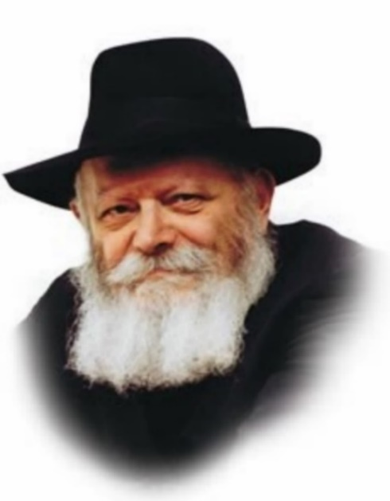

The name of this week's Torah reading is Chayei Sara, literally the "life of Sara." As explained by Rabbi Shneur Zalman, founder of Chabad Chasidism, the Hebrew name of a particular object or creation is what gives it its vitality and sustains it. Thus, we must conclude that the entire Torah portion is somehow connected with the "life of Sara."

This, however, appears difficult to understand at first glance. Only the first verse of the Torah portion relates to Sara's life, whereas the rest of it speaks of seemingly unrelated matters: the marriage of Isaac and Rebecca, and the passing of Abraham. Why then is the entire portion known as Chayei Sara?

The answer is that in truth, all of the events related in Chayei Sara - the marriage of Isaac and Rebecca, as well as the passing of Abraham - express the sum and substance of our Matriarch Sara's life.

Concerning the marriage of Isaac and Rebecca, the Torah tells us, "And Isaac brought her into the tent of Sara his mother, and took Rebecca, and she became his wife." When did Isaac agree to marry Rebecca? Only after he brought her into his mother's tent, and the miracles that used to occur during Sara's lifetime resumed.

Rashi, the foremost Torah commentator, explains that there were three specific miracles: 1) the Shabbat candles Sara kindled burned from one Friday afternoon till the next; 2) the dough she kneaded was specially blessed, and; 3) a cloud of holiness hovered over her tent. After Sara's death these miracles ceased; in the merit of Rebecca, they returned.

This occurred three years after Sara passed away, yet we see in these miracles a continuation of her life.

A similar connection exists to the passing of our forefather Abraham. The Torah states, "His sons Isaac and Ishmael buried him." Isaac is mentioned before Ishmael, for by the time Abraham died, Ishmael had already repented. By giving his younger brother precedence, Ishmael demonstrated that the birthright rightly belonged to him.

This development was in the sole merit of Sara, who when she saw that Ishmael was "mocking," i.e., not behaving properly, demanded that Abraham "cast him out...for he will not be heir." Sara's intent was for Ishmael to return to G-d in repentance, which indeed subsequently occurred. Many years later, after Sara was no longer alive, Ishmael allowed his younger brother to lead the way, again an expression of the continuation of Sara's life.

The entire Torah portion is therefore known as Chayei Sara, as all of the events it relates are connected to Sara's life.

*Reprinted from the Parshat Chaya Sarah 5761/2000 edition of L’Chaim. Adapted from the Lubavitcher Rebbe’s talk on Shabbat Chayei Sare 5736.*

*\*\*\*\*\*\*\*\*\*\*\*\*\*\*\*\*\*\*\*\*\*\*\*\*\*\*\*\*\*\*\*\*\*\*\*\*\*\*\*\*\*\*\*\*\*\*\*\*\*\*\*\*\*\*\*\*\*\*\*\*\*\*\*\*\*\**

*And he fell in the presence of all his brothers...and these are the generations of Isaac* (Gen. 25:18-19)

This is an allusion to the End of Days, when Ishmael will "fall" and will no longer exert dominance over the Jewish people. Moshiach, a descendant of Isaac, will then arise to establish G-d's sovereignty in the world. *(Baal HaTurim)*

*Reprinted from the Parshat Lech Lecha 5761/2000 edition of L’Chaim.*

**Rabbi Berel Wein on**

**Parshat Chaya Sara 5784**

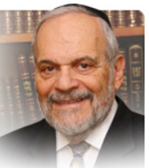

In truth, our mother Sarah, like many other mothers past and present in Jewish life, has not quite received her due. Rashi, quoting Midrash in describing Sarah’s life, states that all the years of Sarah’s life were “for good.” He must mean “for good” in a spiritual and holy sense, for in her physical worldly life there was little good that she experienced.

Wandering over the Middle East by following her visionary husband to a strange and unknown destination; being forced into Pharaoh’s harem; being unable to conceive children; having her maidservant Hagar marry Avraham and attempt to usurp her position in the household; kidnapped by Avimelech, the king of the Philistines; seeing her precious son’s life threatened by an aggressive and violent step-brother, Yishmael; and passing away almost fifty years before her husband – this does not make for a happy resume of a life that was “all good.” In fact, it raises the eternal question of why bad things happen to good people.

But powerless as we are to really answer that question cogently and logically, we should, in retrospect, view our mother Sarah with a renewed sense of awe and appreciation. Lesser people would have been crushed by such a cascade of events in one’s lifetime. The Mishna speaks of the ten tests in life that befell Avraham - and that he rose above all of them. We should also make mention of the tests in life that our mother Sarah endured in her existence and that she too rose above them. “The wisdom of women builds their home,” said King Solomon. That certainly must be said of the house of Avraham, the founding home of the Jewish people. It was Sarah’s wisdom and fortitude that was the foundation of that home.

In everyone’s life there are moments of danger, frustration, disappointment and even tragedy. Who amongst us can say in truth that all the years of our life were “all good?” This being the case we must revert to the understanding that since the “all good” in the life of our mother Sarah must perforce be interpreted in a spiritual sense – in a sense of continual service to G-d and man and a commitment to a higher level of living than mere physical existence and an optimistic frame of mind – so too must we search for such an “all good” interpretation in our individual lives as well.

The striving for finding such an “all good” approach to life is the essence of Torah and Jewish ritual. I once had to attend a rabbinical court here in Israel in order to register as being married. As often happens in government offices here the wait to be serviced was long and the ambience was not very pleasant. The clerk handling the matter was rather surly and disinterested in my problem.

Finally, a wonderful rabbi came out of his inner office and took care of me and my need expeditiously and warmly. When I was foolish enough to begin to complain to him about the long wait and the less than forthcoming clerk, the rabbi gently shushed me and said: “Here in the Land of Israel all is good!” And when one is on that level of spiritually that is certainly true.

Shabbat Shalom

*Reprinted from the current website of rabbiwein.com*

*\*\*\*\*\*\*\*\*\*\*\*\*\*\*\*\*\*\*\*\*\*\*\*\*\*\*\*\*\*\*\*\*\*\*\*\*\*\*\*\*\*\*\*\*\*\*\*\*\*\*\*\*\*\*\*\*\*\*\*\*\*\*\*\*\*\**

Now Avraham was old, well on in years, and Hashem had blessed Avraham with everything. (24:1) Rashi says The numerical value of the word with everything, equals that of son. People spend their entire lives trying to accumulate wealth - have nice cars - beautiful homes - fancy vacations. At Hashem’s whim it can all be lost and they have nothing.

Or even if they do become rich - in their old age - when they try to figure out what they really accomplished they realize it’s all worthless. Avraham realized that in his old age he had everything. Rashi explains to us what Avraham considered everything. He had a son who was following in his ways and who reached great heights. That is what Avraham considered everything. (Emunas Yirmiyahu) (Reprinted from this week’s whY I Matter parsha sheet compiled by R' Yedidye Hirtenfeld.

**In Israel, Reliving the**

**1941 Baghdad Massacre**

**By Rabbi Shraga Simmons**

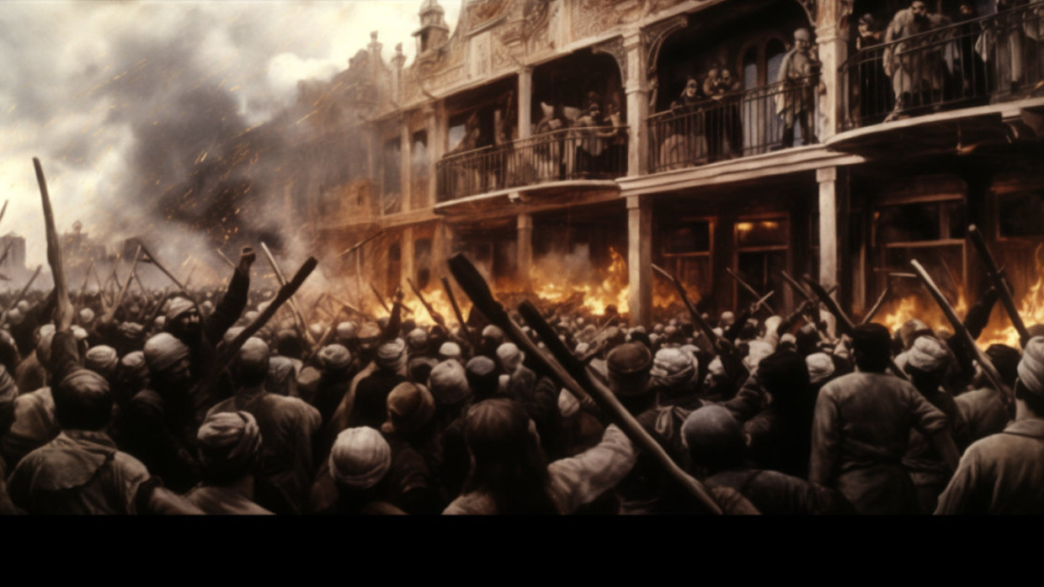

October 7, 2023. The Tel Aviv suburb of Givatayim, 8 pm. Sirens wail, signaling an incoming missile from Gaza.

Oria Jackson rushes to the protected room of her apartment, located on the top floor of a seven-story building.

The horrific Hamas’ massacre of 1,400 Jews and kidnapping of 230 Israelis and foreign nationals earlier that day race through her mind.

Shuddering in her bomb shelter, Oria recalls another terror massacre, 82 years ago in her birthplace of Baghdad, Iraq. During the two-day *Farhud* (“violent dispossession” in Arabic), mobs of Arabs wielding swords, axes and guns invaded thousands of Jewish homes – raping, pillaging, and massacring.

Oria’s thoughts of mutilated bodies, from Baghdad to Gaza, meld in a gruesome mix. Then suddenly – *SLAM!* – a missile from Gaza strikes the roof of Oria's building, just meters from where she sits. The impact and explosion send shock waves, shattered glass and twisted metal hurtling through her apartment.

The protected room, made of reinforced concrete and steel, saves her from violent death.

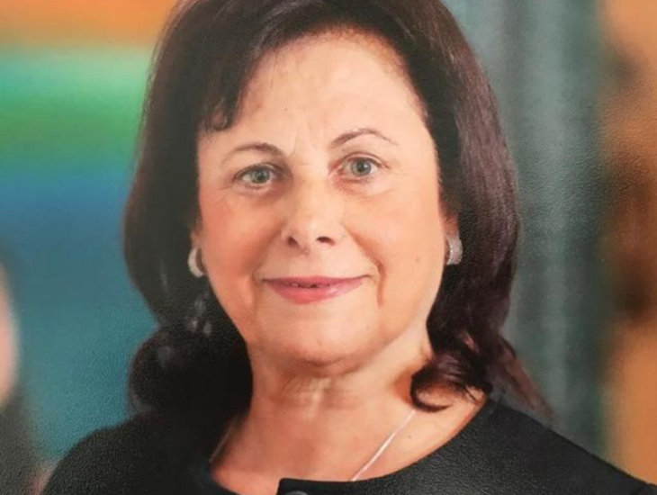

**Oria Jackson**

“I grew up hearing gory details from my parents and six siblings who experienced the horrific Farhud,” Oria tells Aish.com, “but I never imagined the same thing would happen in Israel.”

**Deal with Hitler**

Prior to the *Farhud*, Baghdad was the wealthiest Jewish community in the world. Jews dominated banking, commerce, law and government, and constituted over a third of the city’s population. Jews had lived peacefully in Iraq for 2,500 years; the Babylonian Talmud was developed in present-day Iraq.

All that changed in the wake of World War II. The British were in control of Iraq’s huge oil reserves, a resource that Hitler coveted for his expanding war plans: to first conquer Russia, then the Middle East – exterminating all its Jews. To this end, Nazi General Erwin Rommel’s troops were positioned in Egypt.

Hitler found a willing partner in the Grand Mufti, Haj Amin al-Husseini, the Muslim leader violently opposed to the establishment of a Jewish state (and till today the ideological father of the Islamist movement to annihilate Israel). With nearly one million Jews living in Arab lands, the Mufti feared a mass exodus of these Jews to Israel. Hitler's proposed genocide was a convenient final solution.

The Mufti forged a close alliance with Hitler and visiting Nazi Germany to learn the tactics of ghettos, pogroms, and concentration camps.

On Hitler’s payroll, the Mufti delivered a daily pro-Nazi radio broadcast to the Muslim world, and implemented a vicious anti-Jewish campaign in Iraqi media and schools. The German embassy in Iraq purchased the *Arab World* newspaper*(Al-alam Al-arabi)*and filled it with incendiary hate propaganda about Jews as “subhuman vermin” and “the treacherous enemy.”

*Mein Kampf, Protocols of Elders of Zion,*and Henry Ford’s anti-Semitic writings were translated into Arabic and widely distributed*.* The Futtuwa Iraqi youth movement was established based on the model of Hitler Youth. Posters in Iraq markets declared: “G-d *(Alla)* is your master in Heaven; Hitler your master on Earth.” Iraq’s second-most popular baby name, after Mohammed, was Hitler.

*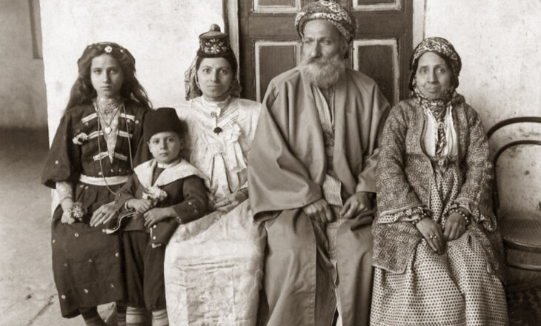****Jewish family in Iraq, circa 1925 (illustrative)***

Adolf Eichmann, on a wartime visit to Palestine, swelled with pride at how "Nazi flags fly in Palestine and they adorn their houses with Swastikas and portraits of Hitler."

High-ranking SS officer Dieter Wisliceny would later testify at the Nuremberg trials: "The Mufti was one of the initiators of the systematic extermination of European Jewry, and had been a collaborator and advisor of Eichmann and Himmler in the execution of this plan... He was one of Eichmann's best friends and had constantly incited him to accelerate the extermination measures."

**The *Farhud* Massacre**

For Baghdad’s Jews, the situation reached a boiling point on May 25, 1941, when Hitler issued Order 30 “to move forward in the Middle East by supporting Iraq.”

One week later, on the eve of the Jewish holiday of Shavuot, tens of thousands of bloodthirsty Nazi-Muslims rampaged through the streets of Baghdad, swearing allegiance to the Mufti and Hitler, and screaming: *“Cutal al Yehud –*slaughter the Jews!”

The Arab marauders went door to door, targeting every Jewish home and business in Baghdad. (The Mufti had prepared for the massacre by ordering a red *hamsa* symbol painted on all Jewish properties.) For two terror-filled days of Shavuot, Arabs plundered and demolished hundreds of Jewish homes and businesses, while hundreds of Jews – men, women and children – were raped and slaughtered.

The *Farhud* was the Middle East version of Kristallnacht, and showed how Hitler’s Jew-hatred had spread to the Muslim world.

Oria's sister, Carmela Zelcha, was five years old at the time of the Farhud.

“When the violence started, we pushed all the furniture against our front door to prevent the mob from breaking in,” Carmela tells Aish.com. “My grandfather paid a local Arab policeman to stand outside the house and protect it. As a child, I overheard the adults speaking about how the Arabs, with their gruesome ways of murdering Jews, outdid even the sadistic Nazis.”

**Zionist Underground**

The *Farhud* was a wakeup call for Baghdad’s Jews who began to realize that, after millennia of peaceful existence in Iraq, their days were numbered. A Zionist underground movement, *Tenua*, was formed to secretly teach Iraqi Jews the foundations of Zionism and the Hebrew language.

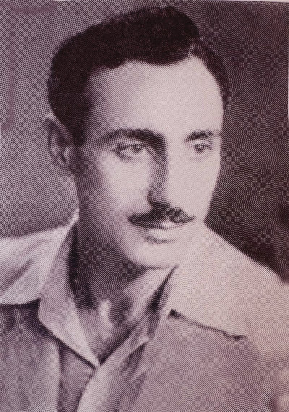

***Yehuda David, a leader of Tenua,***

***the Iraqi Zionist underground***

Yehuda David, the older brother of Oria and Carmela, became a leader of *Tenua*, managing branches in various Iraqi cities. Yehuda obtained weapons – rifles, pistols and grenades – to protect the family in the event of another pogrom.

“The police were always on the lookout for Zionists,” Carmela explains. “One time the police came to our house, so my brother quickly hid the cache of weapons under a floorboard. Police searched the house for hours, but my aunt stood on the spot where the weapons were hidden, not moving the entire time.”

**Border Smuggling**

The situation for Iraqi Jewry turned ominous in 1948 when, following Israel’s declaration of independence, Iraq declared war against the Jewish state. The Iraqi government curtailed Jews’ civil rights and fired many Jewish state employees. Jewish youths and well-connected Jewish businessmen were arrested, tortured and/or publicly hanged. Iraqi Jews, realizing that the Farhud was more than just an isolated incident instigated by Nazi propaganda, sought to leave for Israel en mass.

Leaving Iraq, and escape routes were slow and treacherous.

Herzel Hatka grew up in Khanaqin and became a *Tenua* activist at age 17, illegally smuggling Jews across the border into Iran. These activities were a capital crime, and when a Muslim smuggler “revealed secrets,” Herzel and his brother George, also a *Tenua* activist, were put on the police "wanted list" and forced into hiding.

Herzel tells Aish.com, "We managed to get a message to the central office of *Tenua* in Baghdad, asking for help to get us out of trouble. Yehuda David was in charge of our branch, and his aunt lived in Khanaqin, which gave him freedom to visit the city without arousing suspicion. After we’d been hiding for a few weeks in the attic of a safe house, Yehuda came to help us escape.”

They developed a plan whereby Herzel and George disguised themselves as Bedouin women, wearing black veils and cloaks. They fled Khanaqin by train to Baghdad, then across the border to Iran, eventually arriving in Israel.

**Carmela’s Escape**

Yehuda’s sister Carmela made aliyah to Israel in 1949 at age 13.

“I left my family behind and traveled with a small group of children, as not to arouse suspicion. We weren't able to take anything with us. We first traveled by train to Basra, then by motorboat across the Shatt Al-Arab river that forms the boundary between Iraq and Iran. It was a very dangerous journey. If we'd been caught, that would have been the end.”

After arriving in Iran, Carmela was sent to Tehran, where she stayed in a makeshift tent camp located in a cemetery. From there, she flew to Israel and was placed on a kibbutz with other youth separated from their families. One by one, all of Carmela’s siblings made it to Israel.

Eventually, the Iraqi government permitted Jews to leave the country, on condition they leave all their money, property and possessions behind. Carmela’s parents owned valuable real estate in Baghdad. They wanted to sell the property, but nobody would buy it – because as soon as they left, it would all be free.

In 1951, Carmela’s destitute parents arrived in Israel and the family was reunited. They lived in tent camps *(Mabarot)* until they could afford an apartment. Eventually, they opened a restaurant in Jerusalem.

By 1951, 90% of the Iraqi Jewish community had immigrated to Israel.

*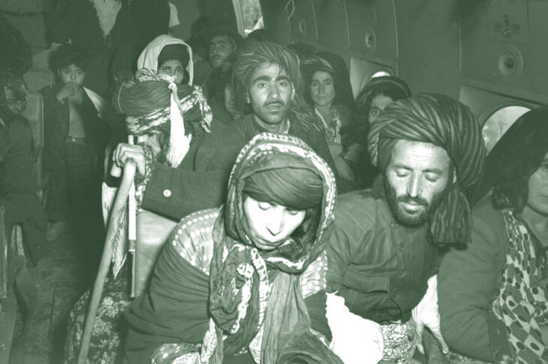****Jews flow from Iraq to Israel, 1951***

**Holocaust Survivors**

An interesting postscript: With Nazi propaganda legitimizing the murder of Jews in Iraq, survivors of the *Farhud* were designated by the Israeli government as “Holocaust survivors,” entitling them to various benefits.

*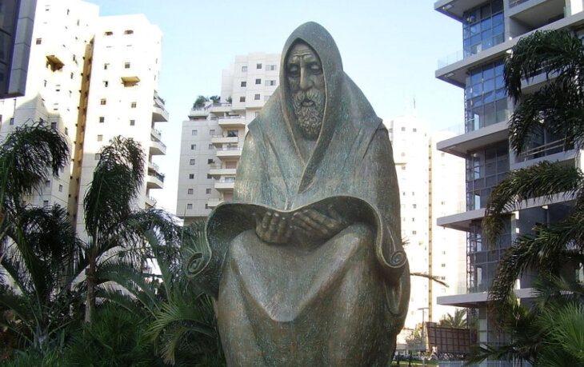****Monument in Ramat Gan, Israel, in memory of Jews killed in the Farhud.***

Orit, whose apartment was hit on October 7 by the missile from Gaza, says she’s not surprised by the Hamas atrocities committed. “The Farhud instilled in me an emotional distrust,” she says. “I always knew of the potential for a massacre. But I never imagined that 82 years later, I’d experience a repeat of the Farhud here in Israel.”

*Thanks to Chava Levin, Noah Omri Levin and Dalia Schwartz for generous assistance in telling this story.*

*Reprinted from the October 30, 2023 website of aish.com*

*\*\*\*\*\*\*\*\*\*\*\*\*\*\*\*\*\*\*\*\*\*\*\*\*\*\*\*\*\*\*\*\*\*\*\*\*\*\*\*\*\*\*\*\*\*\*\*\*\*\*\*\*\*\*\*\*\*\*\*\*\*\*\*\*\*\**

And Sara was a hundred and twenty and seven years old; these were the years of the life of Sara (Gen. 23:1)

As Rashi comments, "All of her years were equal in goodness." Our Matriarch Sara endured much suffering during her lifetime: Childless for many years, she was abducted by Avimelech, wandered about from place to place without a permanent home, and at the end of her life, her only child was about to be offered up as a sacrifice. Nonetheless, she accepted all these trials and tribulations with love, declaring "This is also for the good." (Korban He'Ani)